# Sediment Standards Project Survey:

# What We Heard



August 2025

## **Executive Summary**

### **Purpose**

A partnership undertaken between the British Columbia (BC) Ministry of Environment and Parks (the Ministry) and the Science Advisory Board for Contaminated Sites (SABCS) has launched the first phase of a multi‑year effort to modernize Contaminated Sites Regulation (CSR) sediment standards. The initiative will develop a transparent, risk‑based scientific framework that incorporates bioavailability, contaminant mixtures, and cumulative‑effects endpoints to ensure holistic protection of aquatic ecosystems, including the wildlife and people who depend on them.

In April 2025, the SABCS initiated the Sediment Standards Project to develop a scoping plan for reviewing and updating the CSR sediment standards. The SABCS established the Science and Standards Technical Advisory Committee (SSTAC) to oversee and directly support the Sediment Standards Project, including a multi-faceted public engagement process. On May 30, 2025, the public survey was started to gather feedback on the effectiveness and practicality of the current CSR Schedule 3.4 sediment standards from those who work with them most closely. The feedback from the public survey will be used to inform the next phase of public engagement, which is a half-day session at the Canadian Ecotoxicity Workshop in Victoria on October 27, 2025.

### **Engagement Method**

An online survey was distributed to SSTAC members and other qualified environmental professionals between May 30 and July 31, 2025. This report summarizes the feedback received from respondents (43 complete and 18 additional partial responses), representing a cross-section of expert opinion from environmental consultants, industry representatives, academics, non-government organizations, and government regulators.

### **Key Themes**

The feedback received was detailed and consistent, coalescing around several critical themes:

* **Widespread Dissatisfaction with the Status Quo:** A strong consensus emerged that the current standards are outdated and not sufficiently protective of the environment. A striking 73% of respondents rate the standards as "Not Effective" or "Slightly Effective" at preventing harmful bioaccumulation. A significant concern is their failure to address this pathway, which can lead to contaminants moving up the food chain and posing a risk to wildlife and human health.
* **Practical Challenges in Application:** Respondents highlighted significant difficulties in applying the current standards. Common issues include a limited list of regulated contaminants that omits substances of emerging concern, ambiguity in the classification of "typical" versus "sensitive" sediments, and the standards' failure to account for the bioavailability of contaminants in different environmental settings.
* **The Call for a Broader, More Protective Scope:** Respondents overwhelmingly advocate for a framework that is more comprehensive and protective. This is most evident in the demand to expand the list of regulated contaminants, which 95% of respondents rated as "Essential" or "Very Important." Furthermore, the need to address bioaccumulation was a critical concern, with 68% viewing a "Dual Standard" approach as "Very Necessary" or "Essential."
* **A Mandate for a More Sophisticated, Science-Based Approach:** There is a strong desire to move beyond simple, conservative "bright-line" standards towards a more nuanced, evidence-based system. This is supported by the 91% of respondents who see incorporating bioavailability adjustments as "Essential" or "Very Important," and the 86% who believe a formal, tiered assessment framework would be beneficial.
* **Strong Support for Clear Guidance and Education:** Participants emphasized that new standards, particularly if more complex, must be accompanied by clear, comprehensive guidance documents, standardized methodologies, and accessible training programs to ensure consistent and effective implementation by regulators and practitioners.

### **Conclusion**

The feedback gathered provides a clear mandate and a well-defined direction for updating the BC CSR sediment standards. This input will be instrumental in developing a modernized framework that is more protective of the environment and human health, and more practical for regulators and practitioners to implement across BC's diverse aquatic ecosystems.

## **1. Introduction**

### **1.1 Background**

BC’s diverse aquatic ecosystems, from its rugged coastline and intricate fjords to its thousands of freshwater rivers and lakes, are invaluable ecological, cultural, and economic resources. Sediments form the foundation of these aquatic environments, providing critical habitat for a wide range of organisms. However, sediments can also act as a sink for contaminants, accumulating pollutants over time. These contaminants can then be released back into the water or enter the food web, posing risks to aquatic life and human health.

To manage these risks, the province established sediment standards under the CSR. These standards are intended to be used in the assessment and remediation of contaminated sites to ensure the protection of both environmental and human health. The current sediment standards, found in Schedule 3.4 of the CSR, have been in place since 2003. In that time, scientific understanding of sediment toxicology, contaminant fate and transport, and human and ecological risk assessment has advanced significantly.

### **1.2 Purpose of Engagement**

Recognizing the need to ensure the provincial regulatory framework reflects current science, the SABCS is undertaking a comprehensive review of the CSR sediment standards. A key component of this review is engagement with the professionals who apply these standards in their daily work.

The primary objective of this engagement was to gather expert feedback from environmental consultants, industry representatives, government regulators, academics, non-government organizations and other qualified professionals. The survey sought to understand their perspectives on the effectiveness and practicality of the existing sediment standards and to solicit recommendations for improvement.

### **1.3 Methodology**

An online survey was conducted for two months between May 30 and July 31, 2025. The survey was posted online and distributed to members of the SSTAC to reach and other professionals identified as having expertise in the field of contaminated sites and sediment quality assessment. The survey was advertised using a variety of channels including the Ministry’s [Site Remediation News service](https://www2.gov.bc.ca/gov/content/environment/air-land-water/site-remediation/site-remediation-news), the SABCS website, LinkedIn posts and direct email to contacts who may not be included in the channels used for advertising the survey.

A total of 61 partial and 43 complete responses were received and analyzed. The analysis involved quantitative summaries of multiple-choice questions and a qualitative thematic analysis of open-ended responses to identify key issues, common challenges, and preferred approaches for modernizing the sediment standards.

### **1.4 About This Report**

This "What We Heard" report presents a neutral summary of the feedback received during the engagement period. The views and opinions expressed are those of the survey respondents and do not necessarily represent the position of the SABCS or the Government of BC.

The report is organized into key themes that emerged from the survey data. Direct, anonymized quotes are used throughout to illustrate the perspectives shared by participants. Results from this report will directly inform the project's next phases.

## **2. Overview of Respondents**

The survey successfully reached a targeted audience of highly experienced professionals who work directly with the BC CSR sediment standards. The quality and depth of the responses reflect a strong collective expertise in contaminated sites management, environmental science, and regulatory compliance.

#### **Professional Involvement**

The vast majority of respondents are actively engaged in work that involves assessing or managing sediment quality. This direct, hands-on experience provides a valuable, practice-based perspective on the strengths and weaknesses of the current regulatory framework. As shown in Figure 1, 64% of respondents indicated that their professional work involves assessing or managing sediment quality, with an additional 21% reporting they sometimes engage in this work.

**Figure 1: Does your professional work involve assessing or managing sediment quality? (n=61)**

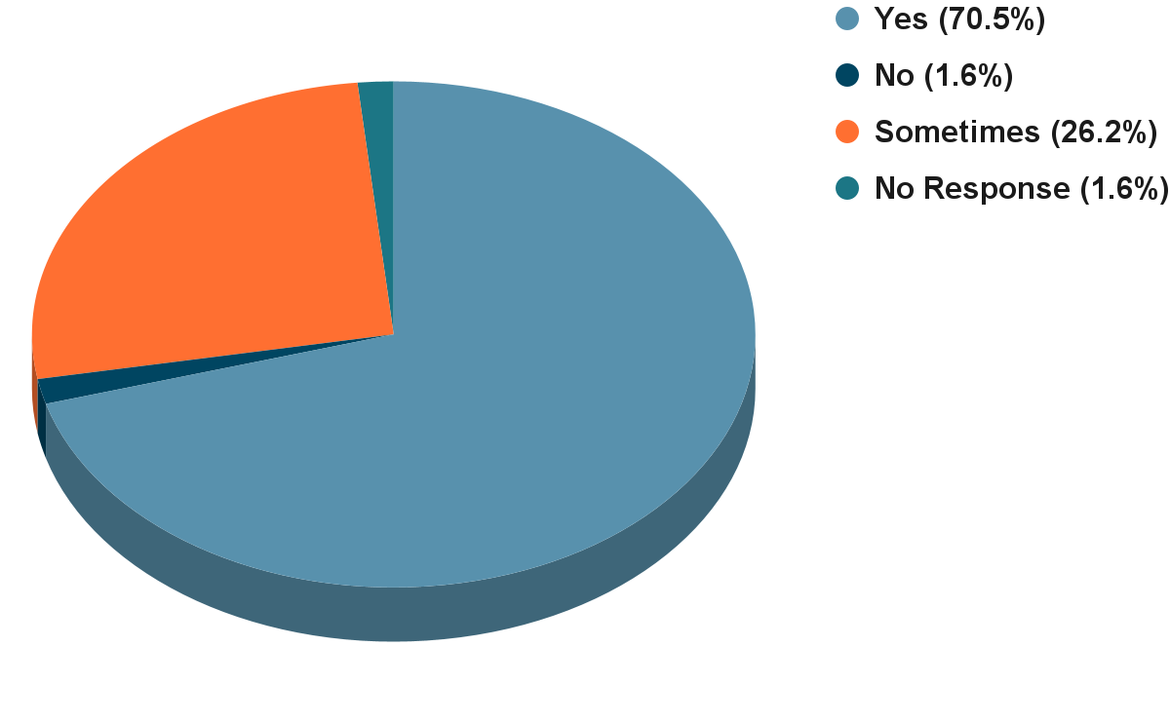

#### **Familiarity with Current Standards**

The feedback received is from a well-informed audience. Over 70% of respondents described themselves as "Very Familiar" or "Familiar" with the current BC CSR Schedule 3.4 numerical sediment standards. This high level of familiarity ensures that the critiques and suggestions provided are not based on speculation, but on years of practical application.

**Figure 2: How familiar are you with the current BC CSR Schedule 3.4 numerical sediment standards? (n = 61)**

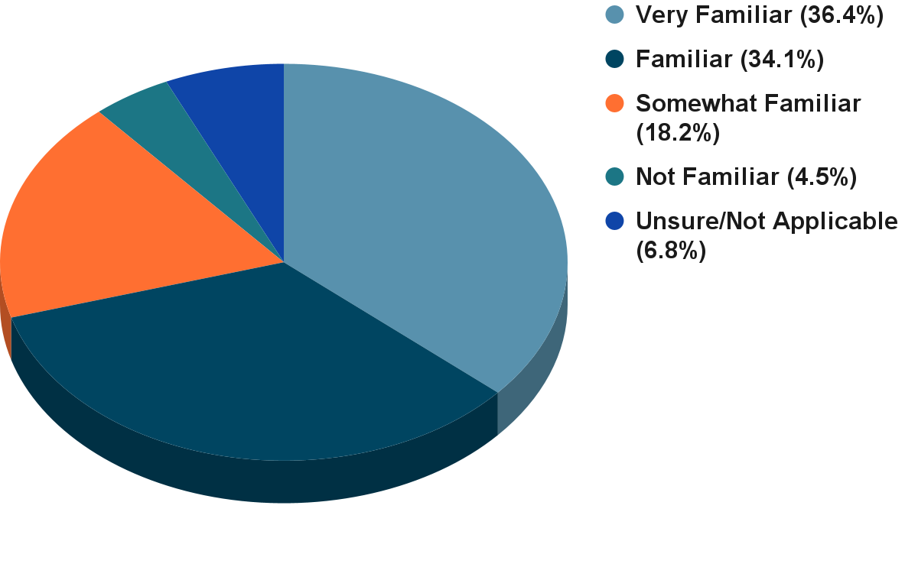

The professional background of respondents was diverse, including environmental consultants, representatives from industry, academics, non-government organizations and regulators from various levels of government. This mix of perspectives provides a balanced and comprehensive overview of how the standards are used and perceived across different sectors. The strong consensus on key issues that emerges from this diverse group underscores the validity of their shared concerns and recommendations.

## **3. Summary of Feedback: Key Themes**

### **3.1 Theme A: Effectiveness of Current Standards**

A predominant theme throughout the survey responses is that the current sediment standards are outdated and not sufficiently protective of the complex aquatic ecosystems in BC. While some respondents see value in the standards as a basic screening tool, the majority believe they fail to address key risk pathways, particularly the bioaccumulation of contaminants.

**Figure 3: Perceived Effectiveness for Protecting Benthic Organisms (n = 59)**

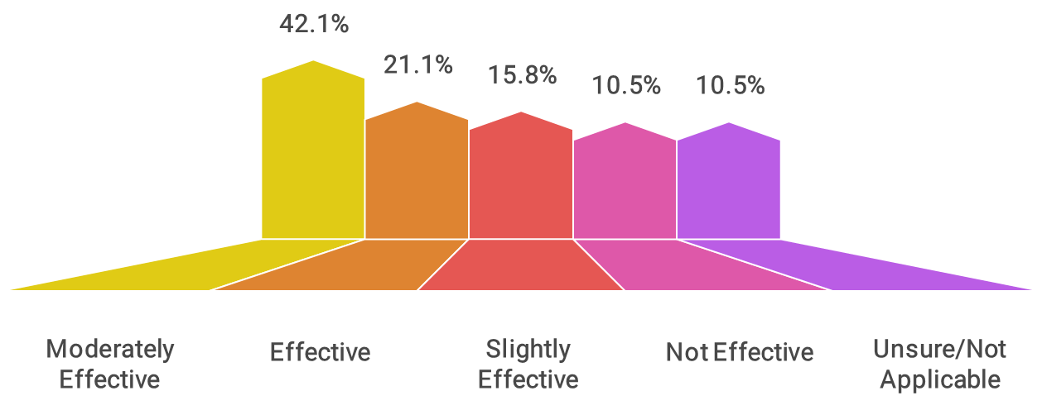

**Figure 4: Perceived Effectiveness for Preventing Harmful Bioaccumulation (n = 59)**

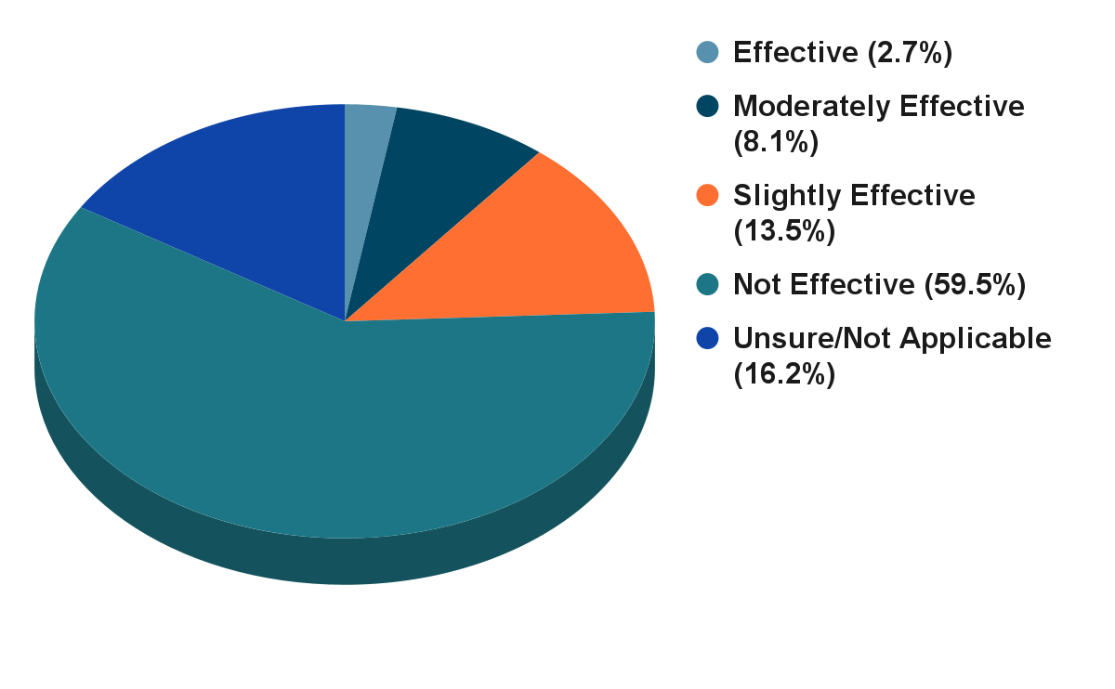

As illustrated in Figures 3 and 4, there is a stark contrast in how respondents view the standards' ability to protect different parts of the ecosystem. While over 60% of respondents believe the standards are at least "moderately effective" at protecting benthic organisms, this confidence plummets when considering the broader food web. A striking 73% stated the standards are "Not Effective" or "Slightly Effective" at preventing harmful bioaccumulation. This points to a critical gap: the standards are perceived as focusing on direct toxicity to sediment-dwelling organisms while largely ignoring the transfer of contaminants up the food chain to fish, marine mammals, and ultimately humans.

This concern was frequently articulated in the written comments, where participants highlighted the limitations of a framework that does not explicitly account for bioaccumulation risks.

*"The BC CSR sediment standards are not appropriate or adequate to protect upper trophic level organisms, apex predators and humans at the top of foodwebs, as these sediment standards were or are designed for the protection of low tropic level species and benthic organisms."* - Survey Respondent 6

*"No bioaccumulation protection is also a scary consideration, resulting in the need to clean up to levels below standards but having a challenging time making a convincing argument."* - Survey Respondent

This lack of bioaccumulation standards was cited as a direct cause of under-protection. One respondent noted an experience where contaminant levels were below the numerical standards, yet tissue sampling revealed that contaminants were accumulating in organisms at levels above critical thresholds. Another pointed out that the standards are not protective enough for Indigenous communities that rely on traditional seafood harvesting, where bioaccumulation poses a direct human health risk.

Conversely, several respondents argued that in certain situations, the standards are *over-protective*. This occurs most often in areas with naturally high background concentrations of metals, where the generic, province-wide standards are lower than what is found in undisturbed local sediment.

*"I know that there have been instances where arsenic and copper concentrations in the Fraser River are naturally higher than the standards, so this would be an example of overprotectiveness."* - Survey Respondent

This "one-size-fits-all" approach can lead to unnecessary and costly investigations or remediation efforts at sites where the elevated concentrations are natural and pose no additional risk to the environment or human health.

### **3.2 Theme B: Practicality and Challenges of Application**

While the current standards are seen as relatively simple to apply—comparing a lab result to a number in a table—respondents identified significant practical challenges that undermine their utility and scientific defensibility.

**Figure 5: Practicality of Applying Current Standards (n = 60)**

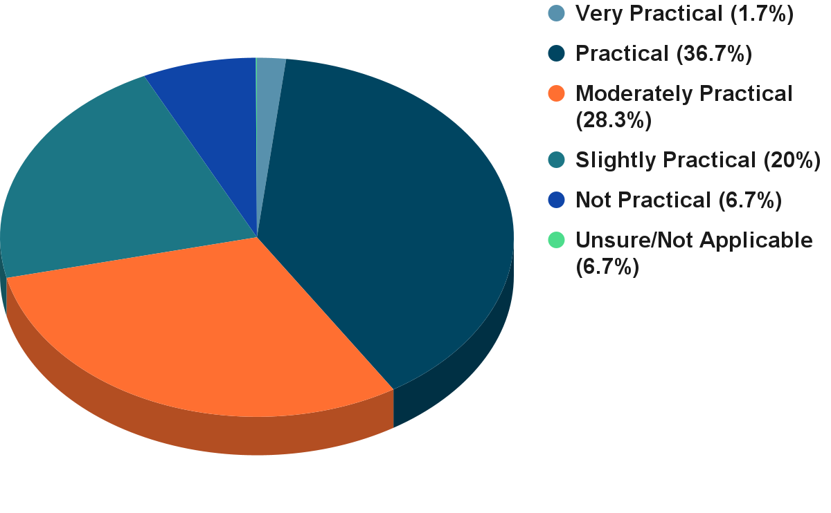

The feedback indicates that the perceived practicality of the standards is largely due to their simplicity, but this simplicity comes at a cost. The most significant challenges identified by respondents relate to the limited scope of the standards, ambiguity in their application, and a lack of scientific transparency.

#### **Issues with Specific Parameters and Contaminants**

A major and recurring criticism is that the list of regulated contaminants in Schedule 3.4 is insufficient and outdated.6 Professionals frequently encounter substances for which no provincial standard exists, forcing them to rely on guidelines from other jurisdictions or conduct costly, site-specific risk assessments.

*"The CSR list of sediment standards is surprisingly short."* - Survey Respondent

*"There are numerous COCs [contaminants of concern] that are not within Schedule 3.4 including TBT. Additionally, there are no human health considerations for sediments."* - Survey Respondent

Respondents specifically highlighted the need for standards for emerging contaminants like per- and polyfluoroalkyl substances (PFAS), current-use pesticides, organotins (e.g., tributyltin), microplastics, and petroleum hydrocarbons (PHCs). The lack of PHC standards was noted as a particular deficiency, with one respondent describing the existing federal models as "too low (not realistic)" for BC conditions.

#### **Methodological and Interpretive Challenges**

Beyond the contaminant list, respondents expressed frustration with the methodology and interpretation of the existing standards.

* **Typical vs. Sensitive Sediments:** The distinction between "typical" and "sensitive" sediments was a common point of contention. The definition of a "sensitive" sediment is seen as overly broad and restrictive, resulting in its default application to nearly all sites, including industrial harbours and marinas. This negates the purpose of having a two-tiered system and can lead to the application of overly stringent standards that may not be achievable or necessary.

*"The typical vs sensitive approach is a bit clunky. At the very least, the terms don't seem appropriate. Benthic organisms in Industrial harbours may still be sensitive even if there's a lower protection goal allowed for those environs."* - Survey Respondent

* **Bioavailability:** A fundamental scientific criticism is that the standards are based on total contaminant concentrations and do not account for bioavailability—the portion of a chemical that is actually available to be taken up by organisms. This can lead to a mischaracterization of risk.

*"The bioavailability in sediment helps us understand not just how much contaminant is present, but whether it is causing harm or influencing environmental processes. This distinction is required to make informed decisions in managing contaminated sites."* - Survey Respondent

* **Lack of Transparency:** Many professionals noted that the scientific basis and derivation documents for the current standards are not readily available. This makes it difficult to understand the level of protection the standards are intended to provide and to justify site-specific modifications when appropriate.

### **3.3 Theme C: The Need for New and Revised Standards**

Given the perceived shortcomings of the current regulations, there is overwhelming support among survey respondents for a comprehensive update. This support is not merely for adjusting existing values but for developing a fundamentally new, more scientifically robust framework for assessing sediment quality.

**Figure 6: How necessary is the proposed 'Dual Standard' approach? (n = 60)**

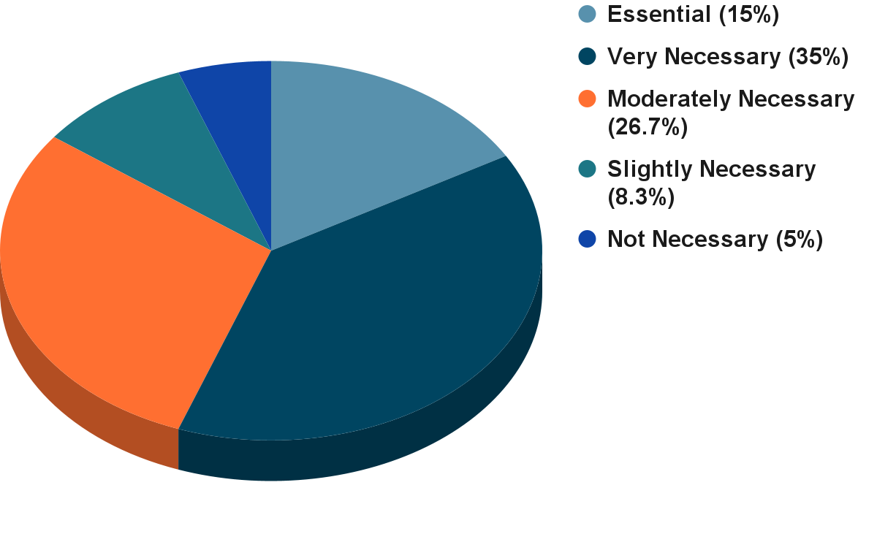

**Figure 7: How beneficial would a formal, tiered assessment framework be? (n = 59)**

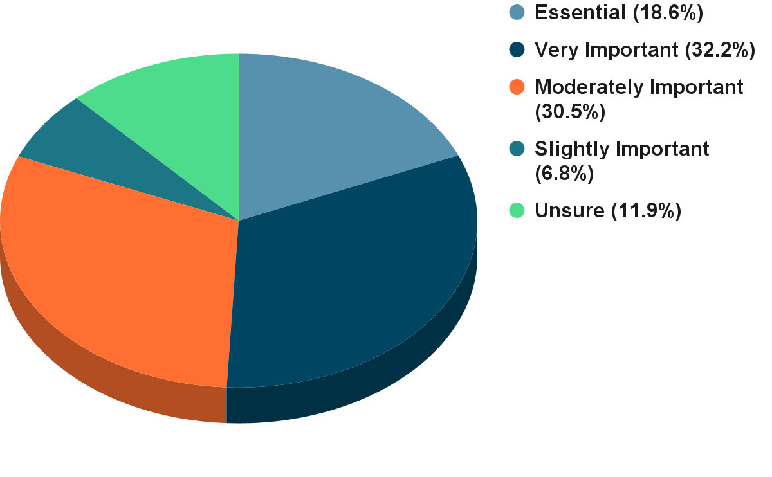

The desire for a modernized framework is clear, with a strong mandate coupled with clear preferences for the *form* these new standards should take.

#### **Key Suggestions for New Standards**

Respondents provided specific, constructive suggestions for developing a more effective and scientifically defensible sediment standards framework.

* **Dual-Standard Approach:** There is strong support for developing separate standards for the protection of benthic organisms (direct toxicity) and for the protection against bioaccumulation (food web effects). This "dual standard" approach is seen as a critical step to address the primary weakness of the current regulations. As one respondent noted, this approach would  
  *"address more receptors (i.e., not just focus on benthic invertebrates)"* and provide a more holistic assessment of risk.
* **Incorporate Bioavailability:** A clear majority of respondents (over 90%) believe it is "Essential" or "Very Important" to systematically incorporate bioavailability adjustments into the standards, using metrics such as Total Organic Carbon (TOC) and Acid Volatile Sulfides/Simultaneously Extracted Metals (AVS/SEM). This would allow for a more accurate assessment of risk by considering the fraction of a contaminant that is actually available to cause harm, rather than relying solely on total concentration.
* **Tiered, Risk-Based Framework:** There is broad agreement (over 86% see it as "Beneficial" or "Very Beneficial") that a formal, tiered assessment framework would improve sediment management in BC. Such a framework would allow for simple screening at Tier 1 using conservative numerical standards, with options for more complex, site-specific investigations at higher tiers. This could include tools like:
  + Food Web Models (FWMs) to simulate contaminant transfer through the food chain.
  + Biota-Sediment Accumulation Factors (BSAFs) to quantify the relationship between contaminant levels in sediment and in organisms.
  + Toxicity Testing to directly measure the effects of contaminated sediment on aquatic life.

*"I believe this [a tiered framework] can be extremely beneficial, especially when combined with a tiered assessment framework."* - Survey Respondent

This approach would provide the flexibility needed to manage the wide variety of sites and conditions found across the province, from remote, pristine environments to complex, industrialized harbours.

### **3.4 Theme D: Data, Guidance, and Implementation**

While there is strong enthusiasm for new, scientifically advanced standards, respondents were equally clear that new rules alone are not enough. The success of a modernized framework depends on robust data, clear guidance, and comprehensive training to support its implementation.

#### **Data Gaps**

A significant barrier to effective sediment quality assessment is the lack of critical data. Respondents identified several key areas where more information is needed:

* **Emerging Contaminants:** The most frequently cited data gap is the absence of standards for contaminants of emerging concern such as PFAS, current-use pesticides, organotins, microplastics, and PHC.
* **Background Concentrations:** There is a need for provincially or regionally established background concentration data for metals and other substances. This would help distinguish between natural and anthropogenic sources of contamination and prevent the misclassification of sites.
* **Bioaccumulation Factors:** To properly assess bioaccumulation risk, BC-specific data is needed, including Biota-Sediment Accumulation Factors (BSAFs) for local species and information on their dietary habits.
* **Sampling and Analysis:** Respondents also called for better guidance on sampling density and methodologies, and improved laboratory analytical methods and lower detection limits to support advanced assessments.

#### **Guidance and Training**

Respondents universally agreed that any new framework must be accompanied by clear, accessible, and practical guidance. There is a strong desire for transparency in how the new standards are developed and how they are intended to be used.

*"Provide decision trees, flowcharts, and worked examples in guidance documents. Integrate chemistry, toxicity tests, and benthic community data in a weight-of-evidence (WOE) approach."* - Survey Respondent

*"That would be dependent on what the future framework is, but at the bare minimum there needs to be a presentation on what was done and how the standards were derived."* - Survey Respondent

Specific requests included webinars, detailed technical documents, and training sessions for both regulators and consultants to ensure the new framework is applied consistently and correctly across the province. This emphasis on implementation support highlights a key lesson from past experience: without proper guidance, even the most scientifically sound regulations can be difficult to apply in practice.

### **3.5 Theme E: Noteworthy Insights**

Beyond the major themes, respondents provided several specific and forward-thinking suggestions that warrant consideration in the standards review process:

* **Human Health Dermal Exposure:** One respondent highlighted a potential gap in human health risk assessment, noting that the rate at which contaminants adhere to skin can be significantly higher in wet, intertidal sediments compared to standard terrestrial soils. This could lead to an underestimation of risk for people using these areas for recreation or harvesting.
* **Future-Proofing for Climate Change:** A novel suggestion was to consider incorporating a temperature factor into the standards. The respondent noted that warmer water temperatures, a consequence of climate change, can increase both the toxicity of certain contaminants and the susceptibility of organisms to them.
* **A "One Health" Approach:** One expert advocated for framing the project through a "One Health" lens, which recognizes the interconnectedness of environmental, wildlife, and human health. This approach would align the updated standards with broader goals of ecological and community well-being.

## **4. Respondents' Preferred Actions & Approaches**

The survey responses provide a clear roadmap for modernizing BC's sediment standards. The feedback moves beyond identifying problems to proposing a suite of preferred actions and approaches. The central theme is a shift from a simple, prescriptive system to a more sophisticated, flexible, and scientifically robust framework that better reflects the complexities of aquatic ecosystems.

Based on an analysis of the survey data, the most frequently recommended actions and approaches are summarized in Figure 8.

**Figure 8: Respondents' Most Recommended Approaches (n = 60, 59, 59, 60)**

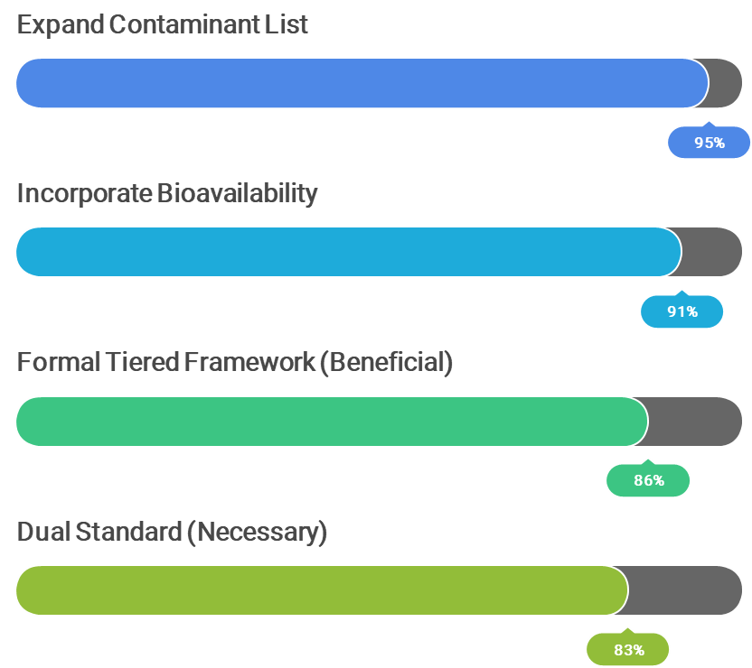

* **Develop Bioaccumulation-Based Standards:** This was the most prominent recommendation. Experts strongly advocate for a "dual standard" approach, with one set of values to protect benthic organisms and another to protect higher trophic levels (including wildlife and humans) from the effects of bioaccumulation. This addresses the most significant perceived weakness of current regulations.
* **Incorporate Bioavailability Adjustments:** There is a strong consensus that standards should not be based solely on total contaminant concentrations. Respondents want a system that accounts for site-specific factors like organic carbon content and AVS, which control how much of a contaminant is actually available to cause harm.
* **Expand List of Regulated Contaminants:** The current list of substances is seen as inadequate. Respondents urged the development of standards for a wider range of chemicals, including emerging contaminants like PFAS, modern pesticides, and PHCs.
* **Establish a Tiered, Weight-of-Evidence Framework:** Professionals support a move towards a more flexible assessment framework. This would allow for simple screening at low-risk sites, while providing clear pathways for more detailed, multi-faceted investigations (e.g., combining chemical analysis with toxicity testing and biological community surveys) at more complex sites.
* **Provide Clear Implementation Guidance:** The call for clear, comprehensive, and practical guidance was universal. This includes the need for transparent documentation on how standards are derived, and decision trees, case studies, and training to ensure consistent application by both industry and regulators.
* **Develop Regional Background Concentrations:** To address the issue of standards being lower than natural levels in some areas, respondents recommended the development of regional background values. This would provide a more realistic baseline for assessing contamination and prevent unnecessary remediation efforts.

## **5. Summing It Up**

The survey engagement process for the Sediment Standards Project has yielded a clear and compelling message from the community of professionals who work with these regulations daily. The feedback demonstrates a strong consensus on the need for change and provides valuable, constructive direction for developing a modernized sediment standards framework for BC.

### **Are we on the right track?**

The overwhelming response from stakeholders confirms that the initiative to review and update the sediment standards is not only welcome but essential. When asked about the necessity of developing new numerical standards, 84% of respondents identified it as either "Very Important" or "Essential." This represents a powerful mandate for reform.

**Figure 12: Is it Important to Develop New Sediment Standards? (n = 43)**

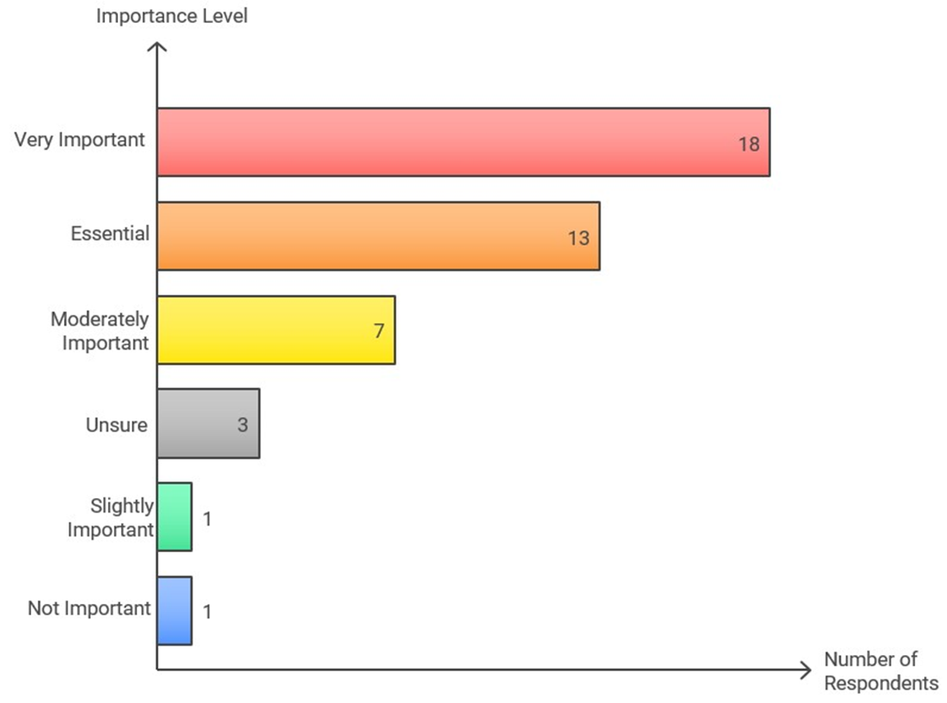

This strong support indicates that the professional community is ready and willing to embrace a new, more scientifically advanced approach to sediment management. The issues raised, from the lack of bioaccumulation standards to the need for clear guidance, are not minor critiques but point to fundamental gaps in the current system that must be addressed.

The input gathered through this survey will be invaluable in guiding the next phase of the Sediment Standards Project. The feedback highlights a clear path forward: developing a robust, tiered framework that includes separate standards for benthic and bioaccumulation protection, incorporates bioavailability, addresses emerging contaminants, and is supported by clear guidance and training. By incorporating this expert feedback, the SABCS and the Ministry can develop sediment standards that are both scientifically defensible and practically applicable, ensuring the long-term health of BC's aquatic environments.

## **6. Appendices**

### **Appendix A: Survey Questions**

1. Does your professional work involve protecting human health or the environment from pollution and/or contamination? (Multiple Choice)
2. Does your professional work involve assessing or managing sediment quality? (Multiple Choice)
3. How familiar are you with the current BC CSR Schedule 3.4 numerical sediment standards? (Rating-scale)
4. In your experience, how effective are the current BC CSR sediment standards at protecting benthic organisms (e.g., worms, clams, insects living in sediment)? (Rating-scale)
5. In your experience, how effective are the current BC CSR sediment standards at preventing harmful bioaccumulation of contaminants in the aquatic food web (e.g., accumulation in fish, wildlife)? (Rating-scale)
6. How practical are the current BC CSR sediment standards to apply in site assessments and management? (Rating-scale)
7. Which aspect of the current BC CSR sediment standards presents the biggest challenge in your work? (Multiple Choice)
8. Please elaborate on the biggest challenge you identified in the previous question, or describe any other significant challenges you face when applying the current BC CSR sediment standards. (Open-ended)
9. Can you provide examples from your experience where the current standards may have been under-protective or over-protective? Please provide the context. (Open-ended)
10. What specific data gaps have you encountered when assessing sediment quality relative to the current BC standards? (Open-ended)
11. The proposed update includes a 'Dual Standard' approach (separate values for benthic protection and bioaccumulation protection). How necessary do you think this approach is for improving sediment management in BC? (Rating-scale)
12. How important is it to systematically incorporate bioavailability adjustments (e.g., using Organic Carbon, AVS/SEM) into the routine application of BC sediment standards? (Rating-scale)
13. Which method for deriving benthic protection standards do you think is most appropriate for BC, considering data availability and scientific robustness? (Rating-scale)
14. How important is it to expand the list of regulated contaminants in BC sediment standards to include substances like PFAS, current-use pesticides, and organotins? (Rating-scale)
15. How beneficial would a formal, tiered assessment framework incorporating multiple lines of evidence be for complex sediment site assessments in BC? (Rating-scale)
16. What are your thoughts on the proposed 'Dual Standard' approach? What potential benefits or challenges do you foresee in its implementation? (Open-ended)
17. What are the key considerations for formally linking sediment quality assessment to Human Health Risk Assessment (HHRA) in BC, particularly regarding fish/shellfish consumption? (Open-ended)
18. Regarding a Tiered Approach (e.g., Tier 1 generic numerical; Tier 2-3 site-specific numerical): What site-specific information and lines of evidence (beyond chemistry) are most critical to include? (Open-ended)
19. Do you have experience with sediment quality frameworks from other jurisdictions (e.g., US EPA, Ontario, Washington State)? Are there specific elements from elsewhere that BC should consider adopting or adapting? (Open-ended)
20. Please provide any other comments or suggestions regarding the scientific basis, policy implications, or practical application of potential updates to BC's sediment standards. (Open-ended)
21. When assessing direct toxicity risk to benthic organisms, which assessment tool(s) do you find most reliable? (Rating-scale)
22. When assessing bioaccumulation risk from sediments, which assessment tool(s) do you find most reliable? (Rating-scale)
23. What type of sediment toxicity testing provides the most valuable information for site assessment in BC? (Rating-scale)
24. How can sediment standards better account for the cumulative effects of multiple contaminants often found at sites? (Open-ended)
25. From a regulatory science perspective, what are the key factors for ensuring updated sediment standards are implementable, enforceable, and achieve the desired environmental protection outcomes? (Open-ended)

### **Appendix B: Methods and Constraints**

**Methodology**

This report summarizes responses from an online survey conducted between May and July, 2025. The survey was designed to solicit feedback from a targeted group of technical experts and stakeholders, primarily members of the SSTAC and other qualified environmental professionals in BC. A total of 61 partial responses and 43 complete responses were received, which form the basis of this analysis. The online survey used Google Forms and was anonymous.

The analysis involved two components:

1. **Quantitative Analysis:** Responses to multiple-choice and rating-scale questions were tallied and are presented as percentages and charts throughout this report to illustrate the distribution of opinions on specific topics.
2. **Qualitative Analysis:** Responses to open-ended questions were compiled and systematically analyzed to identify recurring themes, key issues, and specific recommendations. Direct, anonymized quotes have been selected to provide context and depth to the quantitative findings.

**Limitations**

The findings of this report should be considered within the context of the following limitations:

* **Targeted Audience:** The survey was not distributed to the general public but to a specific group of technical experts. As such, the results reflect the views of this professional community and are not necessarily representative of the broader public or Indigenous Peoples.
* **Sample Size:** While the respondents are highly knowledgeable, the sample size of 43 complete responses is relatively small, but there were an additional 18 responses for some questions, which brings the total participants up to 61. The findings represent a valuable snapshot of expert opinion but may not capture the full spectrum of views within the environmental industry. Numerous organizations indicated that they completed the survey as a team or elected a team member to complete the survey on behalf of the organization.
* **Self-Selection:** Participation in the survey was voluntary, which may introduce a self-selection bias. It is possible that individuals with stronger opinions or specific concerns about the current standards were more likely to respond.